**Manpower Request Test Result 10-20-17**

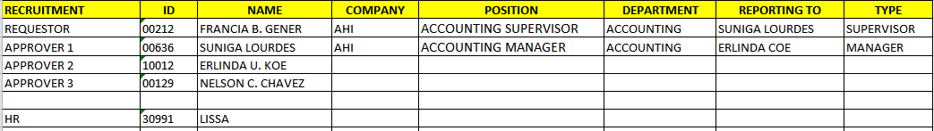

1. **Additional to Existing Position**
2. Sex pick list - add "male or female"
3. PRF listing - wrong requested time posted

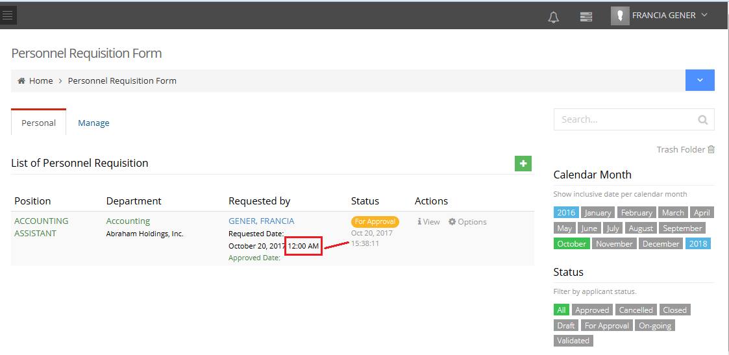

Done

**HR Admin (Lissa)** - wrong requested time and for approval timeposted

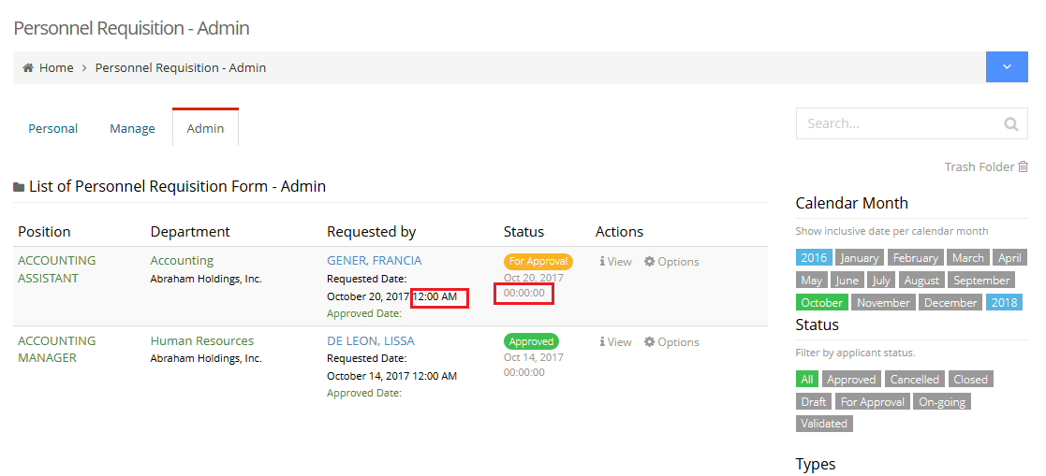

Remove already

1. Pag view ng PRF hindilumabassa list of approver si Approver 1.

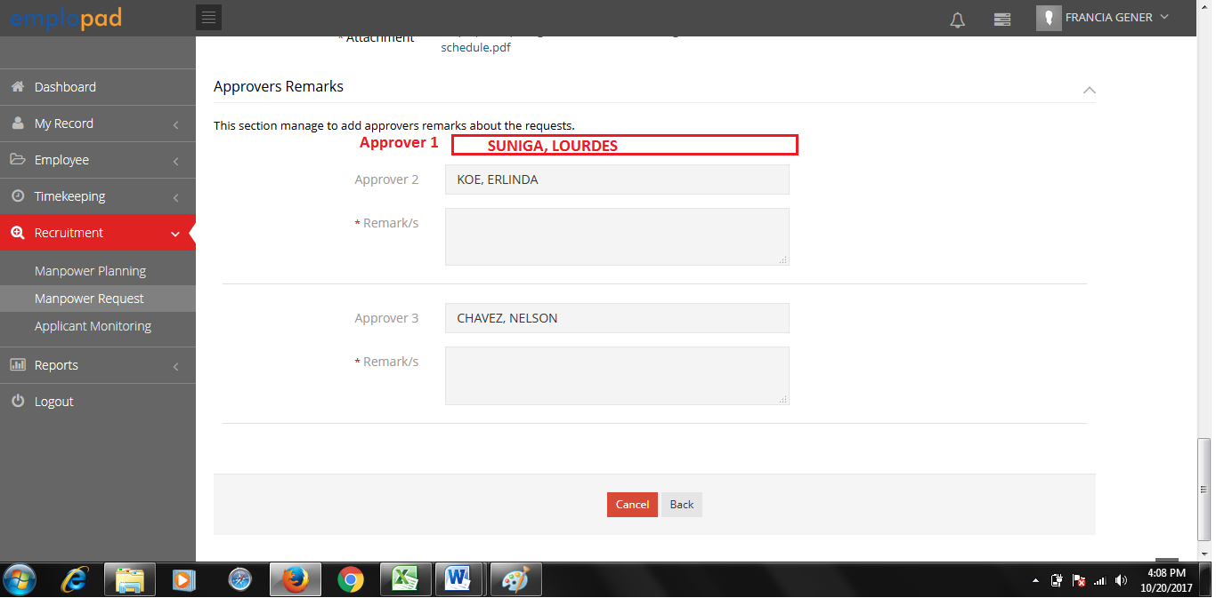

Done

1. After ma-save and send sa approver kitanalahatagadng approver. By level ung setup sa approver.Hindi badapatmakikitalangng 2nd approver after ma approve ni 1st approver?

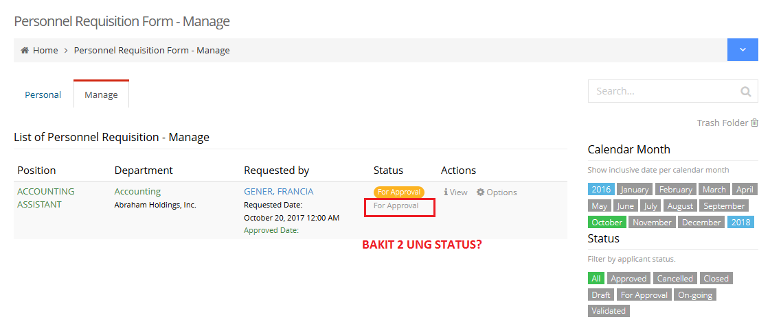**Approver 1 View**

Done

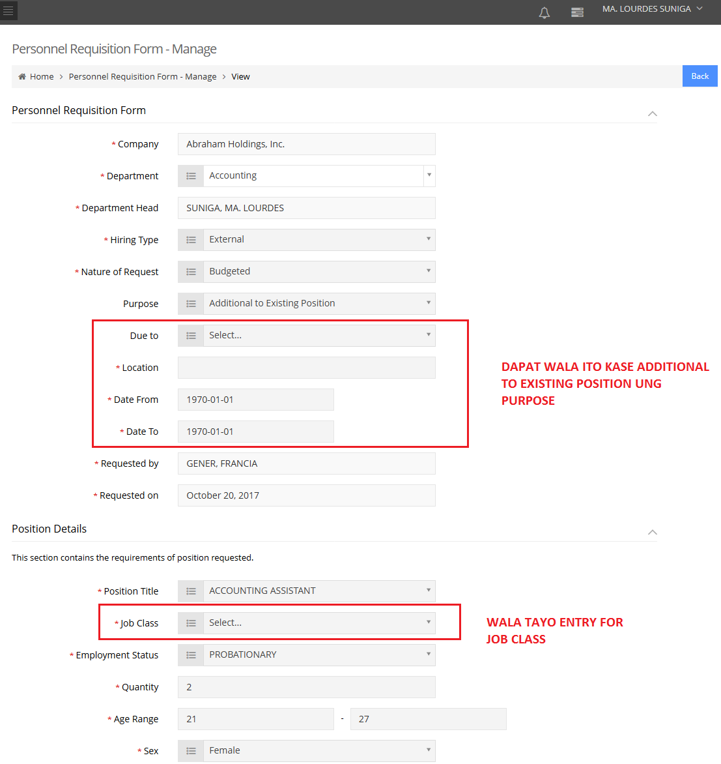

Done

Done

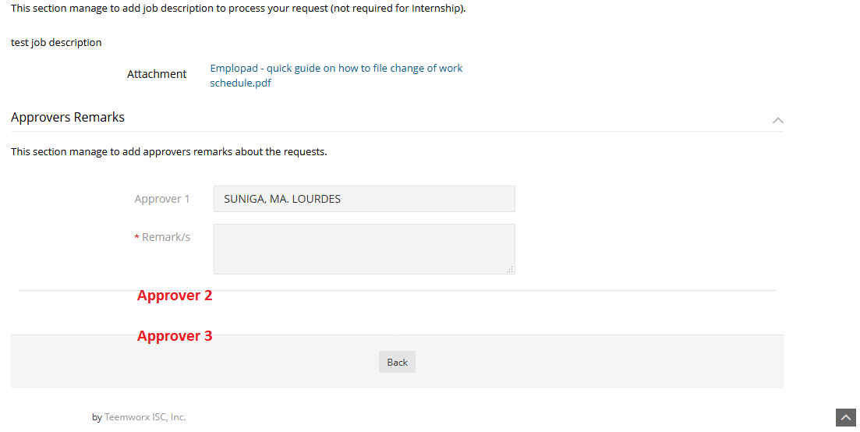

**Approver 2 View**

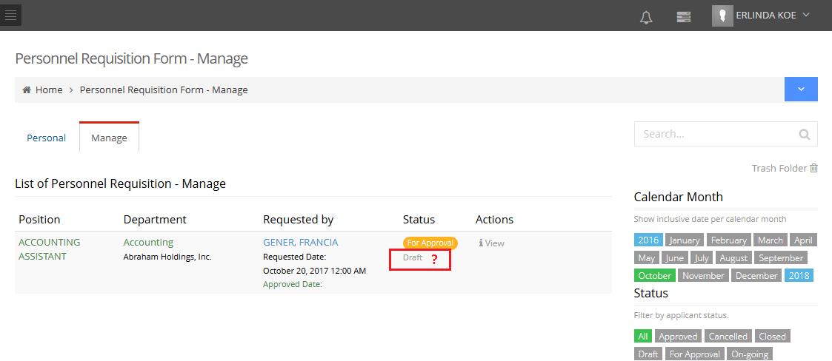

Only on status appear

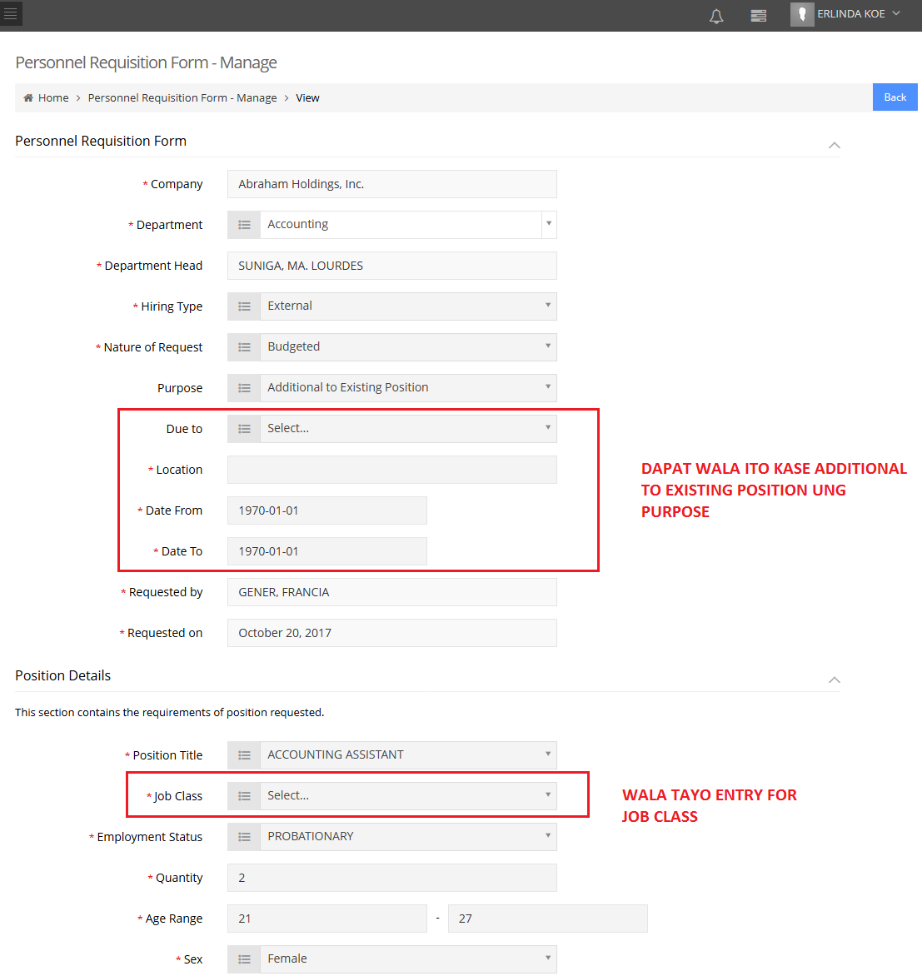if status per approver ungmalitna status, Dapatpala pending ung status instead na draft

Done

Done



**Approver 3 View**

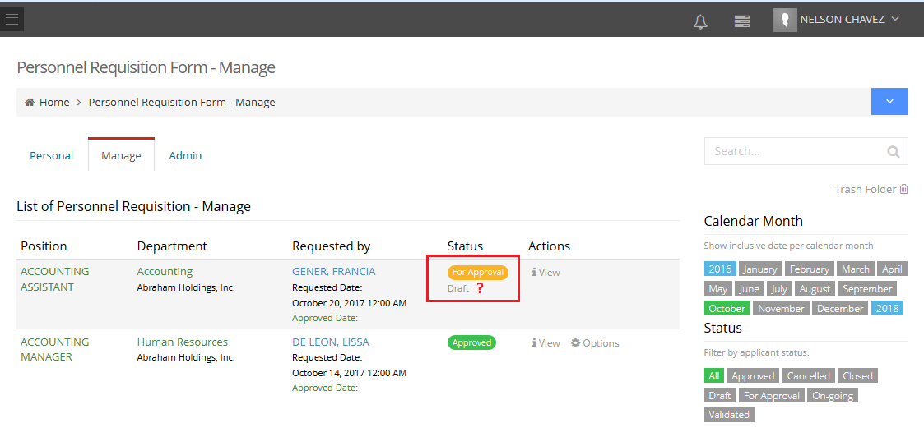

Done

if status per approver ungmalitna status, Dapatpala pending ung status instead na draft

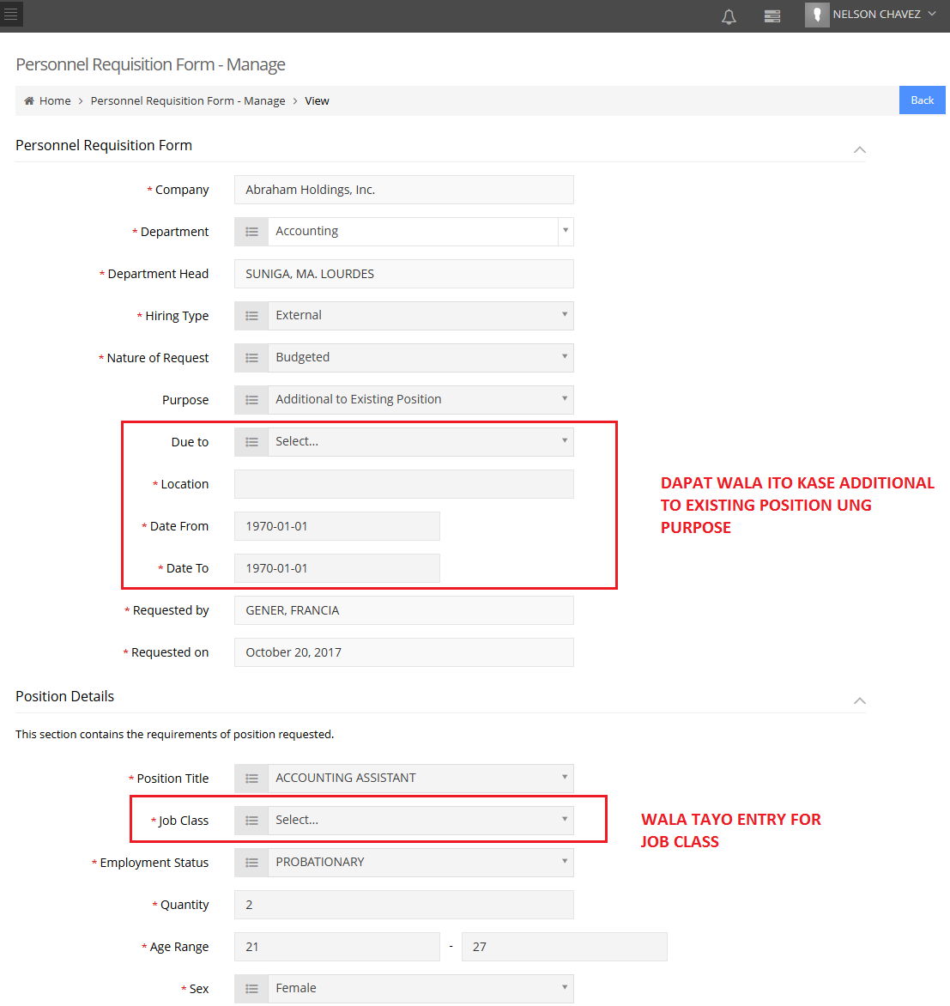

Done

Done



**HR Admin View**

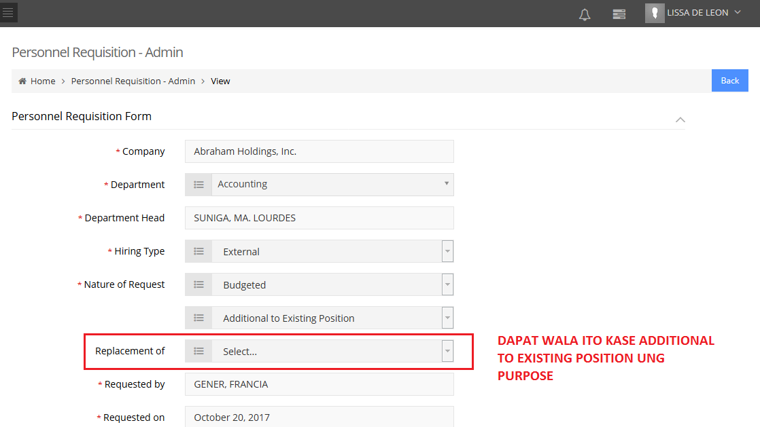

Done



1. **Approver 1 –** approved the prf (walang system notification about prf for approval)

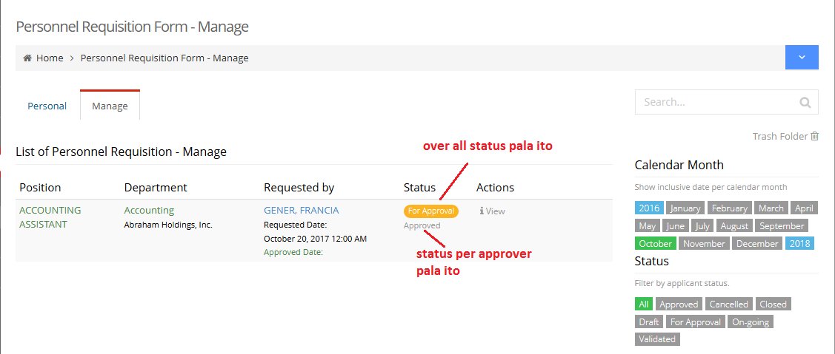

Only one status appear

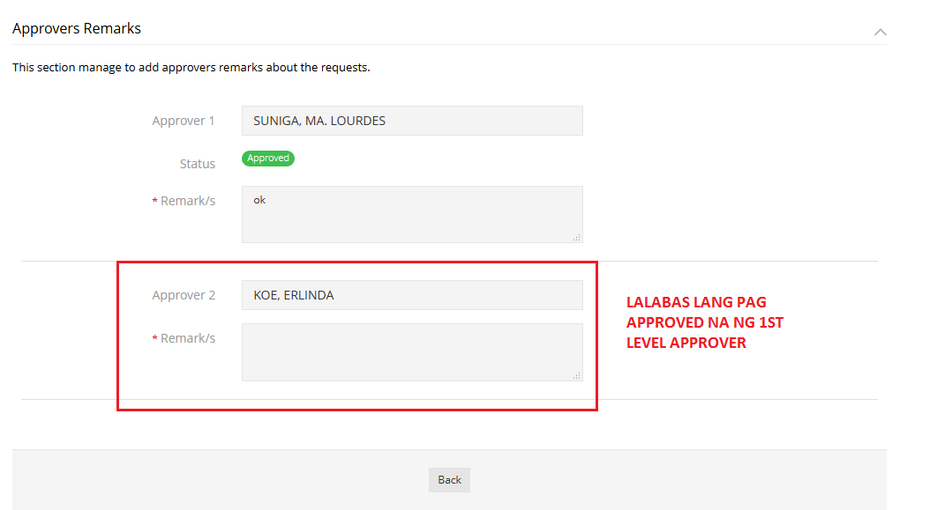

Done

Kindly check I was changed the message

1. **APPROVER 2 -** approved the prf (walang system notification about prf for approval)

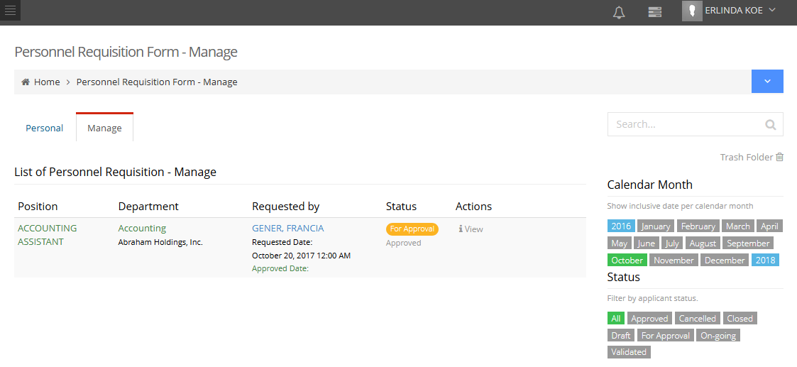

Manage tab only. Done

1. **APPROVER 3 -** approved the prf (walang system notification about prf for approval)

* Sir HR Admin approver pwede mag approve sa manage at sa Admin tab. Hindi bas a mange tab langdapat?

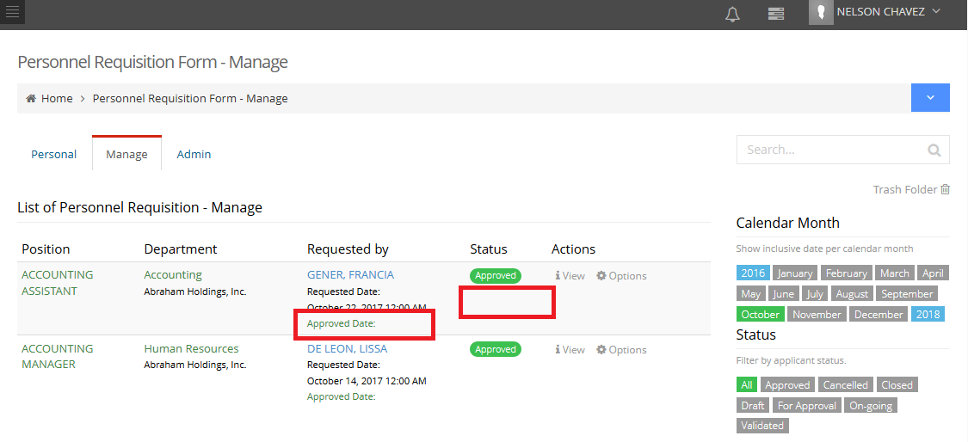

Done

Hindi lumabasung approved date sa manage tab.

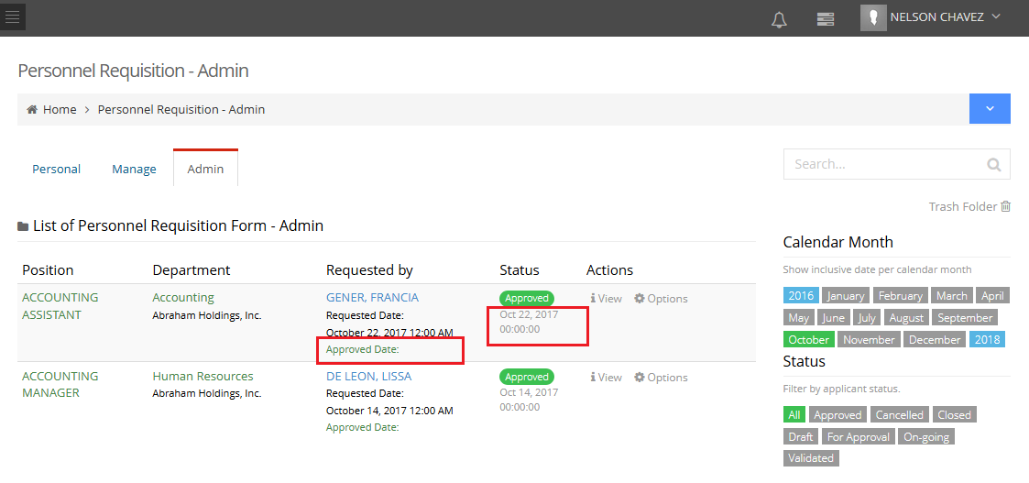

Done

Hindi lumabasung approved datesailalimng requested by. Mali namanung approved time sa status.

1. Requestor list view ng approved PRF

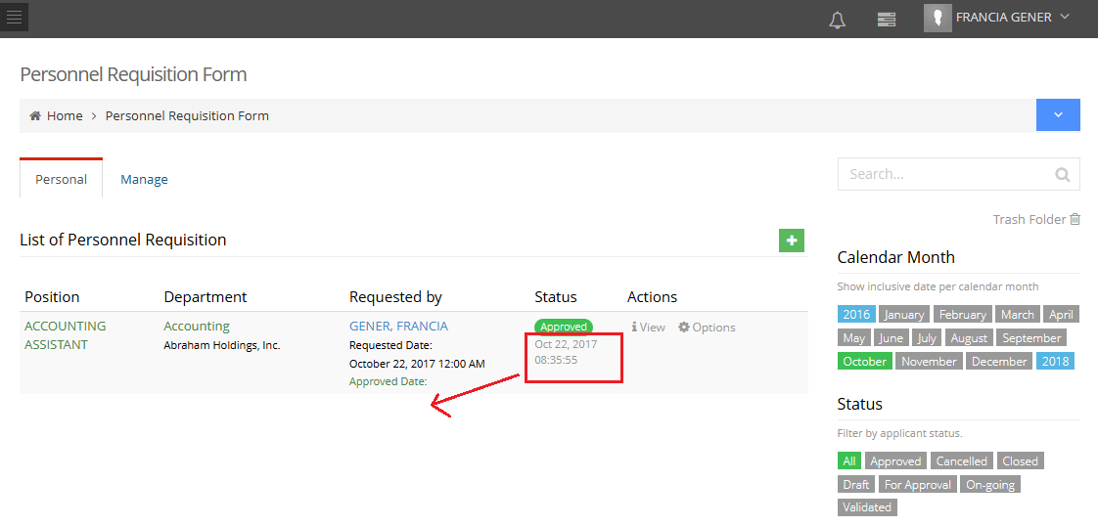

Done

Tama ung approved date and time perodapat dun nanakalagaysailalimng requested date.

1. **New Position**
2. **Replacement**